MATH 2410 – Student Purchasing Options – Fall 2021

BOOKSTORE: The UConn Bookstore has two options to choose from:
- This is the bundle option if you are taking MATH 2410:
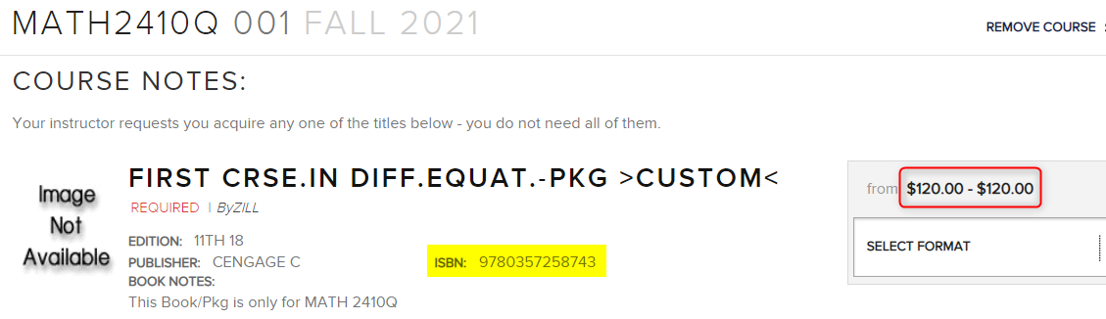

This bundle option contains:
- Zill “A First Course in Differential Equations with Modeling Applications” 11e (Printed Text)
- Zill 11e Student Solutions Manual
- WebAssign Custom Multi-Term Printed Access Code.

2) Cengage Unlimited – You also have the option to purchase a Cengage Unlimited subscription: 1-term / $119.99 1-year / $179.99 2-year / $239.99

ONLINE: You can also purchase through your Cengage account after you register into WebAssign.
WebAssign Option: Multi-Term Access / $155.00
Cengage Unlimited Options: 1-term / $119.99 1-year / $179.99 2-year / $239.99

After registering into WebAssign through your HuskyCT account you can access your Cengage homepage to purchase access through your account. Here you can also enter in an access code you purchased within a bundle through the UConn Bookstore.
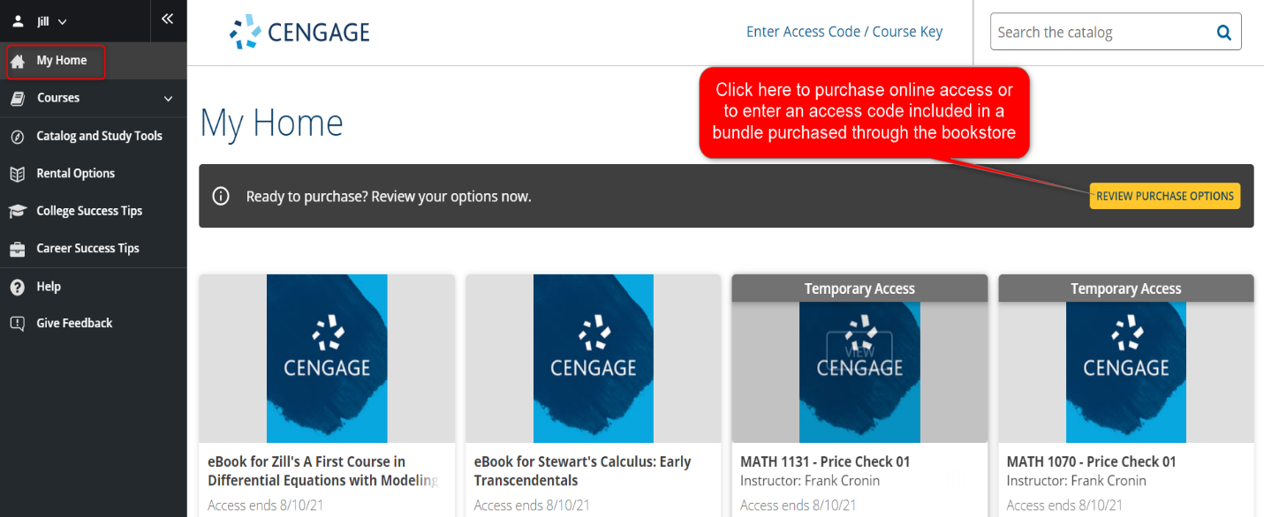

WebAssign Registration/Technical Assistance:
Register into WebAssign through your HuskyCT account. Access your course and register into WebAssign
- Student Registration Video: https://startstrong.cengage.com/webassign-blackboard-ia-no/
- Student Support Services: https://help.cengage.com/student
Students have a 14-day free grace period that starts on the first day of class that allows you access to WebAssign on the first day and provides you some time to make your purchasing choice.

